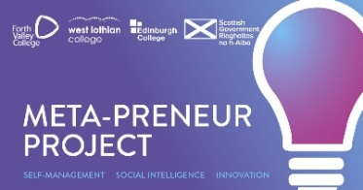
Certificate of Completion & attendance
The Meta-Preneur Programme
★ ★ ★
This certificate is proudly awarded to

(full name)

in recognition of outstanding commitment, engagement and participation throughout
the full Meta-Preneur Programme, delivered in partnership between

West Lothian College, Forth Valley College, Edinburgh College

Through this programme, this learner has developed:
🧠 Self-Management  Focusing, Integrity, Adapting & Initiative | 💡 Innovation  Curiosity, Creativity, Sense-making & Critical Thinking | 🤝 Social Intelligence  Communicating, Feeling, Collaborating & Leading


Programme Lead Signature |  | College Principal |  | Date
 |  |  |  |  |  |  | 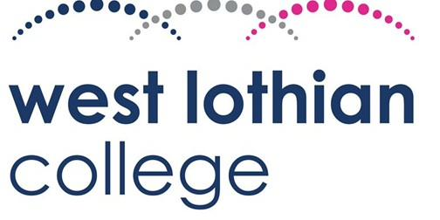 | 

Meta-Preneur Programme · Based on the Skills Development Scotland META Skills 4.0 Framework · Self-Management | Social Intelligence | Innovation

